# Platform overview

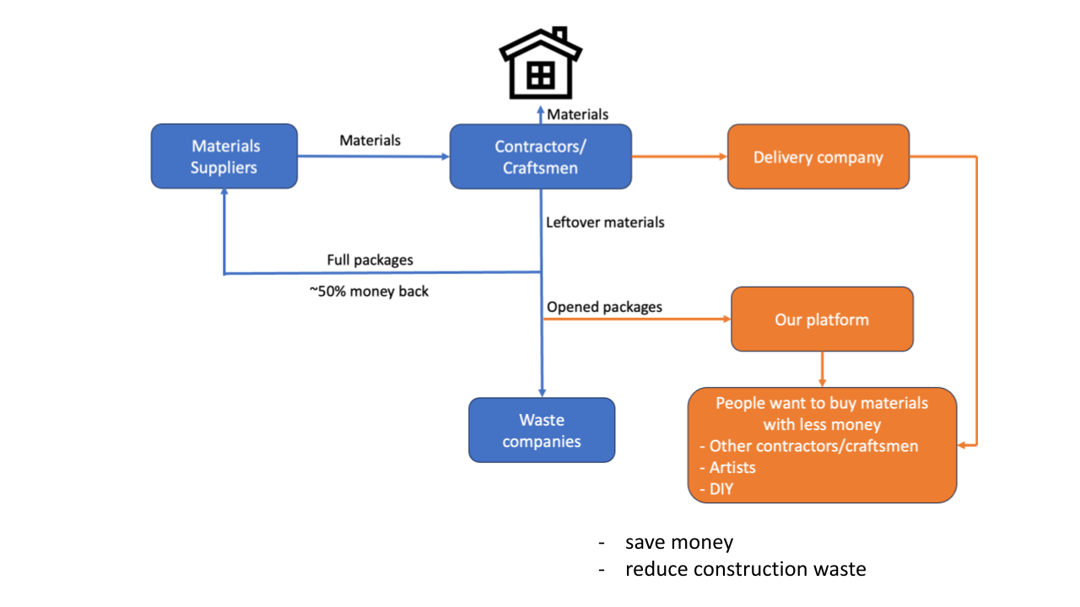

### 1. Executive Summary & Vision

**The Platform:** A specialized B2B2C managed marketplace connecting large-scale construction firms holding excess inventory with Small-to-Medium Enterprises (SMEs), specialized tradespeople (*Handwerkers*), and serious DIYers.

**The Core Value:** We unlock liquidity for large firms by turning their disposal costs (storage/dumping of leftovers) into revenue, while providing smaller buyers access to professional-grade materials at below-market rates—without the platform ever physically touching the goods.

### 2. Operational Strategy: The "Virtual Warehouse" Model

Since you want to avoid warehousing costs, you must operate as a **Managed Logistics Marketplace**. You don't store the goods, but you *must* control the movement of them to ensure quality. Here are three suggested models:

* **Model A: Direct Freight (The "Uber" for Materials)**
  + **How it works:** The seller keeps the material on their site/yard. When sold, your platform automatically pings a connected freight partner (e.g., a pallet network or local courier) to pick it up and deliver it to the buyer.
  + **Pros:** Zero storage cost; you control the customer experience.
  + **Cons:** Requires tight API integration with logistics companies.
* **Model B: The "Inspection & Cross-Dock" (Hybrid)**
  + **How it works:** A truck picks up multiple orders from different sites and brings them to a "Cross-Dock" (a temporary transfer point, not a warehouse) where they are immediately sorted onto delivery trucks.
  + **Pros:** Allows you to inspect quality before final delivery (high trust).
  + **Cons:** Higher logistics complexity.
* **Model C: Seller-Managed Pickup (Click & Collect)**
  + **How it works:** The buyer brings their own van/truck to the construction site at a scheduled time.
  + **Pros:** Zero logistics cost for you.
  + **Cons:** Security risks at construction sites; harder to scale geographically.

**Recommendation:** Start with a hybrid of **Model A** (for heavy items) and **Model C** (for local buyers).

### 3. Enhanced Technical Requirements

To support this model and the "Price Comparison" feature, we need to add these specific modules to your schema:

#### A. Dynamic Price Comparison Engine

To compete with the open market, the platform needs a "scraper" or API aggregator.

* **Requirement:** When a seller lists "Rockwool Insulation," the system searches eBay, Kleinanzeigen, and major retailers (e.g., Hornbach/Obi) for similar keywords.
* **Output:** It displays a "Market Price Range" to the seller to help them price it competitively (e.g., "Average market price: €50. Recommended price for quick sale: €35").
* **Buyer View:** Buyers see a "Savings Badge" (e.g., "You save 40% vs. Retail").

#### B. Standardized "Material Passport" Data

eBay listings are messy. Yours must be professional.

* **Requirement:** Integration with manufacturer databases. If a seller scans a barcode, the system auto-fills the **Fire Rating**, **Thermal Conductivity**, and **ISO Standards**. This is critical for *Handwerkers* who need to meet building codes.

#### C. "Project-Based" Shopping Cart

* **Requirement:** Allow buyers to group items by project (e.g., "Kitchen Renovation"). If they need 5 items but you only have 3, the system should recommend the missing 2 from a partner or standard retailer (affiliate revenue potential).

### 4. Competitive Propositions (How to Beat eBay/Kleinanzeigen)

You cannot beat them on traffic; you must beat them on **Trust** and **Relevance**.

|  |  |  |  |
| --- | --- | --- | --- |
| **Feature** | **eBay / Kleinanzeigen** | **Your Platform** | **Why You Win** |
| **Search** | Text-based (messy) | **Parametric** (Filter by R-value, load-bearing class) | Pros find exactly what fits the building code. |
| **Logistics** | "Pick up only" or expensive shipping | **Integrated Freight** | You solve the "how do I get this pallet of bricks home" problem. |
| **Trust** | "Sold as seen" | **Escrow + Verification** | Money is safe until goods are verified. |
| **Invoicing** | Private sellers (often no invoice) | **VAT/Tax Invoices** | Essential for contractors to claim expenses. |
| **Inventory** | One-off items | **Bulk Lots** | Contractors can buy 500sqm of tiles at once, not just 5 boxes. |

### 5. Barriers to Entry (Protecting Your Market Share)

To limit entry and stop copycats, you need to build "Moats":

1. **Supply-Side Exclusivity (The "Golden Handcuff"):**
   * Sign exclusive disposal contracts with the top 5-10 major construction firms in your region. Offer them ESG (Environmental, Social, and Governance) certificates for reducing waste. If you lock up the supply of high-quality leftovers, buyers *have* to come to you.
2. **The "Data Moat":**
   * As you collect data, you will know exactly how much "Leftover Oak Flooring" is worth in December vs. July. You can eventually offer "Instant Buyback" offers because you know the liquidation value better than anyone else.
3. **Logistics Integration barrier:**
   * Building APIs with freight companies to handle "irregular freight" (pallets, long beams, hazardous materials) is very hard. Once you have this automated, it is too expensive for a new startup to replicate quickly.
4. **Verification Barrier:**
   * Require sellers (construction sites) to use your app to take "geotagged and time-stamped" photos. This proves the item actually exists at that location, eliminating the scams that plague Kleinanzeigen.

### Project Title: B2B2C Managed Marketplace for Construction Material Recovery

#### 1. Executive Summary & Vision

The goal is to develop a specialized web platform that connects large-scale construction companies (Sellers) holding excess, high-quality inventory with Small-to-Medium Enterprises (SMEs), specialized tradespeople (*Handwerkers*), and serious DIYers (Buyers).

The platform aims to unlock liquidity for large firms by turning disposal costs into revenue, while providing smaller buyers access to professional-grade materials at below-market rates. Crucially, the platform must operate on a **"Virtual Warehouse" model**, handling the commerce and logistics logic without the platform operator physically taking possession or storing the inventory.

#### 2. Operational Requirements: The "Virtual Warehouse" Logic

The system must act as a logic layer between the seller's job site and the buyer. Since we will not own or lease storage facilities, the platform’s architecture must solve the following operational challenges:

* **Decentralized Inventory:** The database must handle inventory that is scattered across hundreds of temporary locations (active construction sites) rather than central hubs.
* **Logistics Orchestration:** The platform requires an automated way to connect distinct delivery companies to specific pickup locations based on weight and material type.
* **Open Question for Development:** *What is the most cost-effective logistical flow (Drop-shipping vs. Cross-docking vs. Buyer Pickup) that minimizes liability while ensuring the platform retains control over the customer experience?*

#### 3. Core Technical Specifications

Based on the agreed-upon schema, the platform must include:

* **User Roles:** Unified accounts with tiered verification (Basic for DIYers, Business/Tax ID for Contractors).
* **Real-Time Inventory:** "Infinite scroll" interfaces with deep filtering (Location, Condition, Weight, Dimensions). Items must be removed from the active database instantly upon payment to prevent double-booking.
* **Escrow Financials:** A secure payment gateway that holds funds until delivery is verified.
* **Contextual Chat:** Secure internal messaging linked to specific Order IDs to prevent platform leakage (taking deals offline).
* **Mobile Optimization:** A "Mobile-First" upload flow allowing site managers to list items via smartphone camera in under 2 minutes.

#### 4. Market Intelligence & Price Comparison Engine

To compete with unmanaged marketplaces (eBay, Kleinanzeigen), the platform requires a dynamic pricing tool.

* **Scraping & Aggregation:** The system should be able to query external public marketplaces (eBay, Kleinanzeigen) and retailer APIs to fetch current market prices for similar items.
* **Price Benchmarking:** The UI should display a comparison to the seller during the listing process (e.g., "Average Market Price: €50") and to the buyer during browsing (e.g., "20% cheaper than Retail").
* **Open Question for Strategy:** *How do we legally and technically implement price scraping from competitors to provide real-time value comparisons without getting blocked?*

#### 5. Competitive Propositions (Differentiation from eBay/Kleinanzeigen)

The platform must technically support features that generalist marketplaces cannot offer.

* **Standardized Data:** Unlike the messy text descriptions on classified sites, our platform must enforce structured data (ISO standards, Fire Ratings, R-Values) that professional contractors require for building codes.
* **Tax Compliance:** The system must automatically generate VAT invoices for every transaction, a critical requirement for business buyers that private sellers on classified sites rarely provide.
* **Bulk Logistics:** The platform must support "Project-Based" carts, allowing buyers to purchase heavy bulk items (pallets of bricks, tons of steel) with integrated freight calculation, which is currently a friction point on consumer sites.

#### 6. Market Defense & Barriers to Entry

We need to engineer specific features and business rules that protect our market share and limit entry for copycats.

* **Supply Chain Integration:** How do we technically integrate with the inventory management systems of large construction firms so that their "waste" is automatically listed on our platform? (Creating a "Golden Handcuff" on supply).
* **Trust & Verification:** The platform must employ strict identity verification and geo-tagged photo requirements to eliminate scams, creating a "Safe Zone" that unverified marketplaces cannot match.
* **Open Question for Growth:** *What mechanisms can we employ (e.g., exclusive disposal contracts, proprietary pricing data, or complex logistics API integrations) to create a high barrier to entry for potential competitors?*

### Next Steps for Development

* **Phase 1:** Design the Database Schema and User Flows.
* **Phase 2:** Build the MVP (Minimum Viable Product) focusing on the "Virtual Warehouse" logistics and Escrow payments.
* **Phase 3:** Develop the Price Comparison Engine and Integrations.

### This is my preferred color theme:

/* Color Theme Swatches in Hex */

.Lisbon-Oriente-Station-1-hex { color: #A6375F; }

.Lisbon-Oriente-Station-2-hex { color: #121940; }

.Lisbon-Oriente-Station-3-hex { color: #A3BFD9; }

.Lisbon-Oriente-Station-4-hex { color: #735D55; }

.Lisbon-Oriente-Station-5-hex { color: #F2F2F2; }

/* Color Theme Swatches in RGBA */

.Lisbon-Oriente-Station-1-rgba { color: rgba(165, 54, 95, 1); }

.Lisbon-Oriente-Station-2-rgba { color: rgba(17, 24, 63, 1); }

.Lisbon-Oriente-Station-3-rgba { color: rgba(162, 191, 216, 1); }

.Lisbon-Oriente-Station-4-rgba { color: rgba(114, 92, 84, 1); }

.Lisbon-Oriente-Station-5-rgba { color: rgba(242, 242, 242, 1); }

/* Color Theme Swatches in HSLA */

.Lisbon-Oriente-Station-1-hsla { color: hsla(337, 50, 43, 1); }

.Lisbon-Oriente-Station-2-hsla { color: hsla(230, 56, 16, 1); }

.Lisbon-Oriente-Station-3-hsla { color: hsla(208, 41, 74, 1); }

.Lisbon-Oriente-Station-4-hsla { color: hsla(16, 14, 39, 1); }

.Lisbon-Oriente-Station-5-hsla { color: hsla(0, 0, 95, 1); }

#### 1. Platform Overview

The platform connects contractors and contracting companies as sellers and buyers for material that has been leftover. It serves as a bridge for DIYers and smaller contractors to access affordable materials while allowing companies to offload excess stock.

#### 2. User Accounts & Authentication

The platform should have a unified account system. It should offer several login options or one account that can be used for both functions (buying and selling) seamlessly.

* **Verification:** There should be an email verification once someone signs up. The system needs ways to verify authenticity based on the user type: basic verification for DIYers and business verification (uploading licenses/IDs) for new sellers to verify identities.
* **Profile Management:** Users should be able to save default addresses and payment methods.
* **Security:** The platform requires Multi-Factor Authentication (MFA) for security, especially for high-volume sellers.

#### 3. Inventory Management & Database

It should have a database that is updated with every item added and purchased, allowing inventory management for sellers. When something is purchased, it should be removed from active inventory immediately to prevent double-booking.

* **Item Details:** The inventory should include the location of the items, quantity, and exact estimates—for example, by weight, size/dimensions, or count.
* **Photo Uploads:** Sellers should be able to upload photos. The system must have a requirement that checks the file metadata to ensure photos are less than 2 weeks old, ensuring the condition is current.
* **Bulk Actions:** Sellers with large stocks should be able to upload inventory via a spreadsheet (CSV/Excel) rather than one by one.

#### 4. Shop & Marketplace Functionality

The platform can have a shop function integrated to view sales. Users looking for cheap options should be able to scroll through all items without having to change the page (like used electronics shops), utilizing infinite scrolling.

* **Categorization:** The products listed can have categorizations—new, opened and not used, cut but not damaged, slightly damaged with a description and photos of the damages.
* **Filtering & Maps:** Users should be able to filter by condition, price, and location. Since materials are heavy, a map view should be available to see items nearby.
* **Search Alerts:** The platform requires a "Watchlist" or alert feature. Users can save search criteria (e.g., "Oak wood under $100") and the system should notify them automatically if a matching item is added later.

#### 5. Transactions & Financials

The platform should be able to handle transactions and transfers using an escrow service model to ensure delivery and trust.

* **Escrow Logic:** Funds are held by the platform and only released to the seller once the buyer confirms pickup or delivery.
* **Sales Dashboard:** Sellers should have a dashboard to view active sales, pending orders, and total earnings.
* **Tax & Invoicing:** The system must calculate relevant taxes (VAT/Sales tax) and allow sellers to export transaction history or generate invoices for accounting purposes.

#### 6. Logistics & Delivery

The platform should have a way to connect common delivery companies so they have the required information on pickup times and location, delivery place, weight, and other required details.

* **API Integration:** The system should generate shipping quotes automatically based on the weight and dimensions entered in the inventory.
* **Self-Pickup:** There should be an option for "Buyer Pickup" which allows users to schedule a specific time slot to collect the item themselves.
* **Returns:** The platform needs a logic flow for cancellations and returns. If a return is approved, it should generate the necessary return labels and hold funds until the item is returned.

#### 7. Communication

It should have a chat function that is secure to enable users to communicate without having to leave the platform.

* **Context:** The chat should be linked to the specific item being discussed.
* **Privacy:** The system should prevent the sharing of personal phone numbers or emails until a transaction is officially confirmed.
* **Attachments:** Users should be able to share additional photos or documents within the chat.

#### 8. Mobile Optimization

The platform must be fully responsive and optimized for mobile browsers. Contractors will likely be uploading inventory directly from a job site using a phone.

* **Camera Integration:** The mobile interface should integrate directly with the device's camera for easy photo uploading without needing to transfer files to a computer first.
* **Touch Targets:** Buttons for critical actions (Buying, Contacting) should be large enough to be easily tapped on a smaller screen.
* **Site Usage:** Contractors are often on-site; the interface needs to work well on small screens.
* **Camera Access:** The mobile version should allow sellers to take photos and upload them directly to the inventory without transferring files to a computer.

#### 9. Notifications

Since leftover material is unique and sporadic, buyers might not find what they need immediately. The platform should have a "Saved Search" or "Alert" function.

* **Criteria:** Users should be able to set criteria (e.g., "Oak flooring, under $500, within 20km") and save it.
* **Automation:** The database needs a background job that checks new listings against these saved searches and notifies the user automatically when a match is added.
* **Triggers:** Alerts should be sent for new messages, order confirmations, status changes (e.g., "Ready for Pickup"), and search matches.
* **Channels:** Notifications should be delivered via email and in-app alerts (and optionally SMS for urgent updates).

#### 10. Administration & Content Management

The platform should have an admin side for resolving disputes and managing the system.

* **Dispute Resolution:** Admins need tools to view transaction logs and chat history to resolve issues (e.g., item not as described).
* **CMS (Content Management System):** The platform needs a way to update static text—like Terms of Service, Privacy Policies, and FAQs—without changing the code.
* **Ratings:** After a transaction, users should be able to rate each other to build a reputation system.

### 11. Cancellation & Returns Logic

Distinct from disputes, the platform needs a standard logic flow for cancellations and returns before the admin needs to get involved.

* **Time Windows:** The system should enforce cancellation windows (e.g., a buyer can cancel within 1 hour of purchase without penalty).
* **Return Logistics:** If a return is approved, the system should be able to reverse the logistics flow (generating a return label or pickup request) and hold the escrow funds until the item is back with the seller.

### 12. Data Export (Accounting Integration)

Contracting companies (sellers) need to account for every item sold for tax and inventory auditing.

* **Export Function:** The platform requires a function to export transaction history into standard formats like CSV or PDF.
* **Details:** This export must include the Buyer's name, transaction date, subtotal, taxes collected, and platform fees deducted.

### 13. Content Management System (CMS) for Static Pages

The platform needs a way to update text without changing the code. This is for the "Legal" and "Help" sections.

* **Legal Documents:** Areas to host and update Terms of Service, Privacy Policy, and Liability Disclaimers (crucial for construction materials).
* **FAQs:** A searchable Help Center where admins can easily post answers to common questions about shipping weights or payment methods.

Here is a sample sketch of a very rough preliminary idea that needs to be refined to have a better storyline:

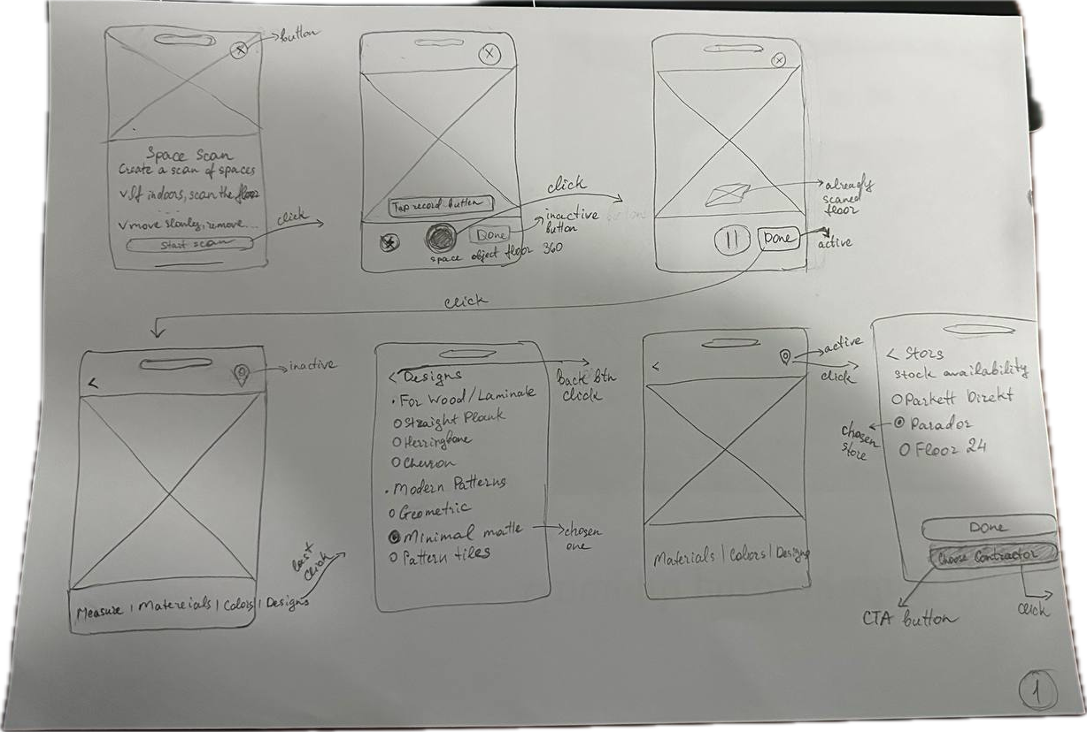

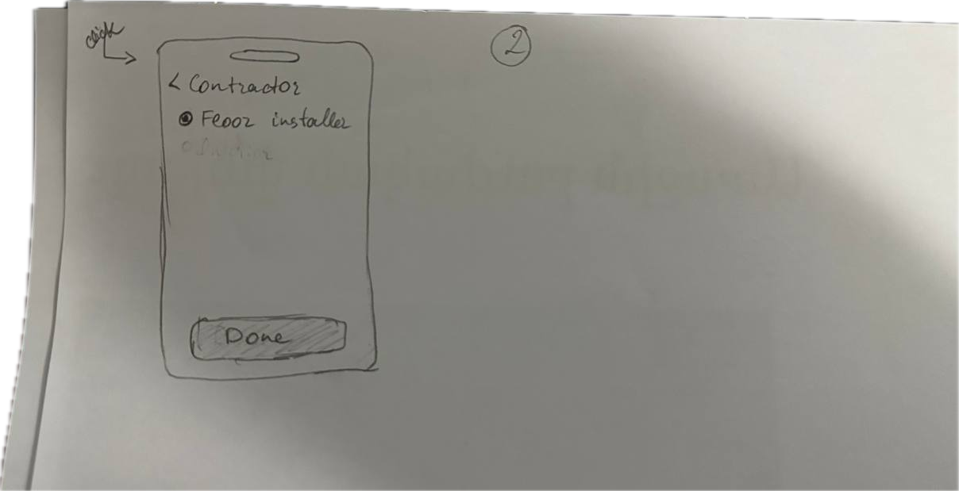

These are some of the questions that the platform should answer:  
**Contractors and Construction Companies**

1. *Do you usually order material for flooring (or electrical, plumbing, facades) in excess?*
   1. *How do you handle the procurement process?*
   2. *Do you have material delivered in batches as required or do you have it all delivered at once?*
2. *In cases of excesses, what do you do with leftovers that have not been used in the construction?*
   1. *If you return to the seller, how much do you get back for the material?*
   2. *If the seller declines, what do you do?*
3. *Does your company have a policy for handling such leftovers?*
4. *If recycled, do you pay for the recycling or does the recycling company give you money?*
5. *On average, how much do you estimate can be leftover from one project?*
6. *How do you handle material that was delivered but became slightly damaged after delivery z.B scratched tiles?*
7. *Would you use such high quality material to complete a smaller project cheaply?*
   1. *If so, how would you go about it?*
   2. *If not, why?*
8. *Have you received requests to use the leftover materials before? If so, from whom?*

**Possible Users - Contractors, Artists, DIYers,**

1. *Have you recently - built a house, renovated a house/room, done a DIY project, made art- that required high quality material like those used in construction?*
2. *How did you go about sourcing material?*
   1. *Was it easy?*
   2. *How expensive was it compared to what you thought it would cost?*
3. *If you buy it online:*
4. *What platform do you often use?*
5. *Is it easy to find your target materials?*
6. *Is it provide enough useful information for you? How about the quality of images?*
7. *Are the prices reasonable?*
8. *Does it have a function of compare product? Do you think this function is necessary? If so, what features should we compare?*
9. *Are there any uncomfortable when using it?*
10. *Did you need to register to use this platform or not?*
11. *How about the delivery policy? Do you like it or not? Why?*
12. *Do you trust this platform?*

**Stakeholders - Delivery company??**

**Manufacturers**

1. *How often is a defective batch produced?*
   1. *what is done with the products?*
   2. *how do you gauge level of defect?*
   3. *Sellability?*

## Here is a proposed database schema:

### 1. User Management Tables

This handles the "single account" requirement and the tiered verification.

**Table: Users**

* **id:** (Primary Key) Unique User ID.
* **email:** User's email (for verification/login).
* **password_hash:** Encrypted password.
* **is_verified:** Boolean (True/False) - linked to email link click.
* **role:** Enum (User, Admin). *Note: All users are buyers by default; becoming a seller requires the table below.*
* **created_at:** Timestamp.

**Table: Seller_Profiles**

* **user_id:** (Foreign Key) Links to Users.
* **business_name:** Display name for the shop.
* **tax_id:** For verification (VAT/Business License).
* **verification_status:** Enum (Pending, Approved, Rejected).
* **stripe_account_id:** Links to Stripe Connect for payouts.
* **default_pickup_address:** Text.

### 2. Inventory Tables

This handles the complex product details, photos, and "infinite scroll" filtering.

**Table: Products**

* **id:** (Primary Key).
* **seller_id:** (Foreign Key) Links to Users.
* **title:** Short name of material.
* **description:** Full text description.
* **category:** Enum (Wood, Metal, Masonry, Electrical, etc.).
* **condition:** Enum (New, Opened_Unused, Cut_Undamaged, Slightly_Damaged).
* **quantity:** Integer (Current stock).
* **unit_of_measure:** Enum (kg, ton, sqm, count, linear_meter).
* **weight_per_unit:** Float (Critical for delivery API calculation).
* **dimensions:** Text (e.g., "2x4x8").
* **location_lat:** Float (Latitude for map view).
* **location_long:** Float (Longitude for map view).
* **status:** Enum (Active, Reserved, Sold, Archived).

**Table: Product_Images**

* **id:** (Primary Key).
* **product_id:** (Foreign Key) Links to Products.
* **image_url:** Link to AWS S3 storage.
* **capture_date:** Timestamp (Extracted from metadata to ensure < 2 weeks old).
* **is_primary:** Boolean (Main image shown in search).

### 3. Transaction & Escrow Tables

This handles the money, escrow states, and tax.

**Table: Orders**

* **id:** (Primary Key).
* **buyer_id:** (Foreign Key).
* **seller_id:** (Foreign Key).
* **total_amount:** Decimal (Product cost + Shipping).
* **tax_amount:** Decimal.
* **escrow_status:** Enum (Funds_Held, Funds_Released, Refunded, Disputed).
* **payment_intent_id:** Stripe transaction reference.
* **created_at:** Timestamp.

**Table: Order_Items**

* **id:** (Primary Key).
* **order_id:** (Foreign Key).
* **product_id:** (Foreign Key).
* **quantity_sold:** Integer.
* **price_at_purchase:** Decimal (Locks the price in case seller changes it later).

### 4. Logistics Tables

This connects the order to the delivery companies or pickup scheduling.

**Table: Shipments**

* **id:** (Primary Key).
* **order_id:** (Foreign Key).
* **method:** Enum (Carrier, Self_Pickup).
* **carrier_name:** Text (e.g., "DHL Freight", "Uber Freight").
* **tracking_number:** Text.
* **pickup_time_slot:** Timestamp (For self-pickup scheduling).
* **delivery_status:** Enum (Pending, Picked_Up, Delivered, Returned).

### 5. Communication Tables

This secures the chat and links it to specific items.

**Table: Conversations**

* **id:** (Primary Key).
* **product_id:** (Foreign Key) Links chat to the item context.
* **buyer_id:** (Foreign Key).
* **seller_id:** (Foreign Key).
* **status:** Enum (Open, Archived).

**Table: Messages**

* **id:** (Primary Key).
* **conversation_id:** (Foreign Key).
* **sender_id:** (Foreign Key).
* **content:** Text.
* **attachment_url:** Link to file/photo.
* **read_at:** Timestamp (For "Read" receipts).

### 6. Administration & Trust Tables

**Table: Reviews**

* **id:** (Primary Key).
* **order_id:** (Foreign Key).
* **reviewer_id:** (Foreign Key).
* **rating:** Integer (1-5).
* **comment:** Text.

**Table: Saved_Searches (Watchlist)**

* **id:** (Primary Key).
* **user_id:** (Foreign Key).
* **keywords:** Text (e.g., "Oak").
* **max_price:** Decimal.
* **radius_km:** Integer.